GuideXP TechLauncher Client Meeting Minutes

Meeting No. 5

6pm, 1 Moore St Civic

March 21, 2019

Meeting Chaired by Client, Open at 6:05PM

# Attendees:

Jayden Castillo Client

Irenez Zhen Client

Raj Kataria Client(Phone)

Liang Hong u6303287

Rutai Sun u6227336

Danny Feng u6611178

Yuanze Niu u6401780

Yu Qiu u6063921

Kelin Zhu u5746348

# Agenda:

1): Reflection from our tutor

2). Techniques

3). Server

4). Data structure

5). IP agreement

6). Roles

# Discussions

* We decide to visit the National gallery of Australia and the National portrait gallery to do an investigation about asking for information from the gallery and visitors’ feeling about the works of art.
* We explain design diagram from the tutorial.

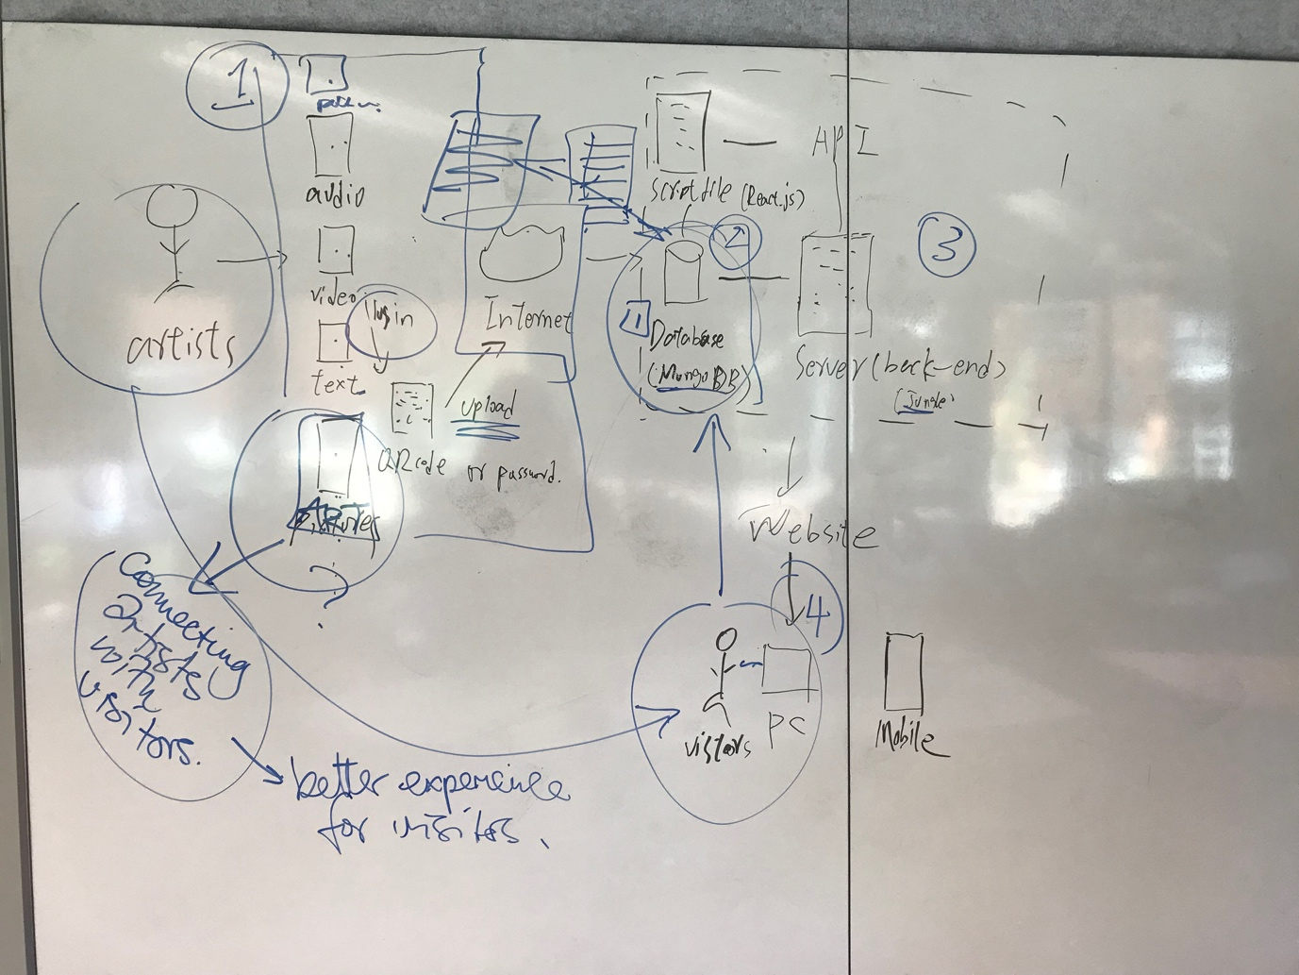

* We make the decisions about use Django as web framework, use React as front-end framework, use mongo dB as database and develop website local test first.
* We might split the roles according to real situations.